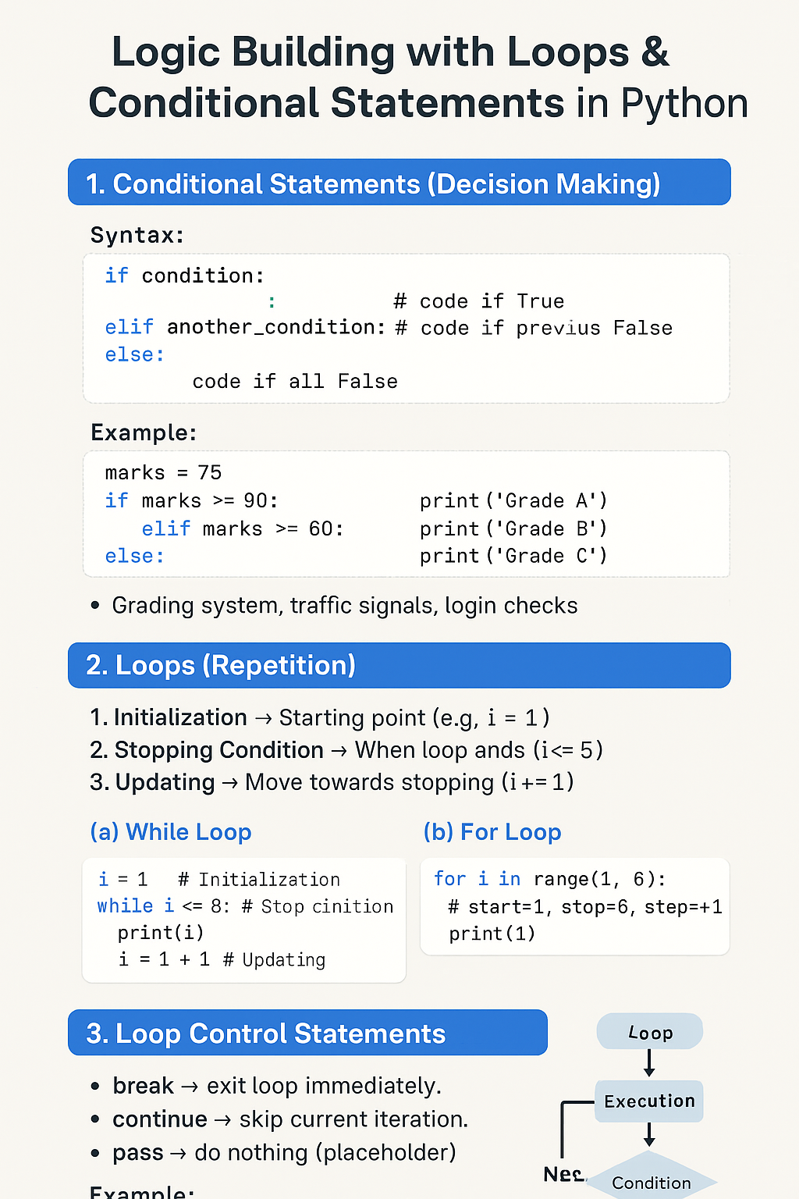

https://chatgpt.com/s/t_68d67500e2208191a6c0df7f4eb38f5b
🧩 Logic Building with Loops & Conditional Statements in Python

🔹 1. Conditional Statements (Decision Making)
Syntax:
if condition:
# code if True
elif another_condition:
# code if previous False
else:
# code if all False
Example:
marks = 75
if marks >= 90:
print("Grade A")
elif marks >= 60:
print("Grade B")
else:
print("Grade C")
✅ Use Case: Grading system, traffic signals, login checks.

🔹 2. LOOPS (REPITITION) WITH DATA STRUCTURES
Loops repeat tasks until a condition is False. OR LOOPS ARE USED TO ITERATE OVER ELEMENTS IN DATA STRUCTURES ALLOWING OPERATIONS ARE TO BE PERFORMED ON EACH ELEMENT EFFICENTLY
3 Main Steps in Loops
- Initialization → Starting point (e.g., i = 1)
- Stopping Condition → When loop ends (i <= 5)
- Updating → Move towards stopping (i += 1)

(a) While Loop
Used when you don’t know how many times, run until condition is False.
OR REPEAT AS LONG AS CONDITION IS TRUE
i = 1 # Initialization
while i <= 5: # Stopping condition
print(i)
i = i + 1 # Updating

(b) For Loop
Used when you know the range. OR ITERATES OVER A SEQUENCE (E.G LISTS, TUPLES, SETS, DICTIONARIES)
for I in range(1, 6): # start=1, stop=6, step=+1
print(i)

🔹 3. Loop Control Statements
- break → exit loop immediately.
- continue → skip current iteration.
- pass → do nothing (placeholder).
for i in range(1, 6):
if i == 3:
continue # skip 3
print(i)
👉 Output: 1 2 4 5

🔹 4. Nested Loops (Loop inside Loop)
for i in range(1, 4):
for j in range(1, 4):
print(i, "x", j, "=", i*j)
👉 Useful in patterns, tables, 2D arrays.

🔹 5. Loop with Else
for i in range(5):
print(i)
else:
print("Loop finished")
👉 Runs else only if loop did not break.

📘 Quick Practice Examples
✅ Even or Odd
num = 7
if num % 2 == 0:
print("Even")
else:
print("Odd")

✅ Sum of Numbers (1 to N)
n = 5
total = 0
for i in range(1, n+1):
total += i
print("Sum =", total)

✅ Multiplication Table
num = 3
for i in range(1, 11):
print(num, "x", i, "=", num*i)

✅ Factorial
n = 5
fact = 1
for i in range(1, n+1):
fact *= i
print("Factorial =", fact)

✅ Prime Number Check
n = 11
is_prime = True
for i in range(2, n):
if n % i == 0:
is_prime = False
break
if is_prime:
print("Prime")
else:
print("Not Prime")
🚀 Summary
✔ Conditionals (if/else) → decision making.
✔ Loops (while, for) → repeat tasks.
✔ Loop Components → Initialization, Stopping, Updating.
✔ Extras → break, continue, pass, nested loops, loop with else.
✔ Logic Building = combining all these to solve problems.

